Boundary-Value Problems

6.5 The Laplace Equation in Polar Coordinate

The Laplace equation in polar coordinate is written as

∇²u = 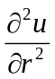 + 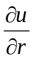 + 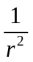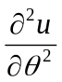 = 0

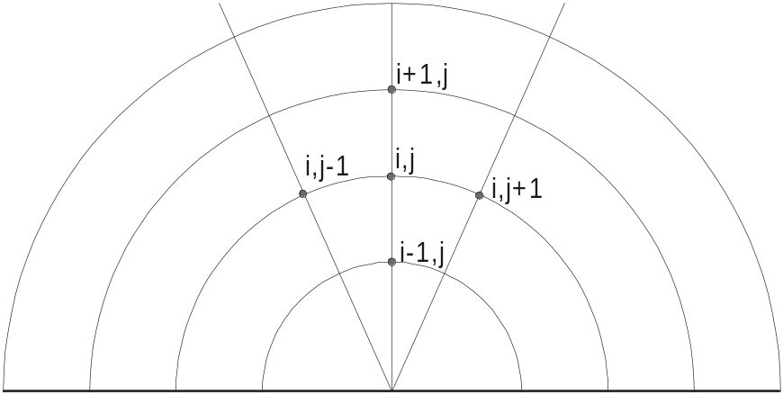
Figure 6.5-1 Index notation in polar coordinate.

Let i and j be the index in the r and θ directions respectively, the finite difference form of the Laplace equation is written as

∇²u = 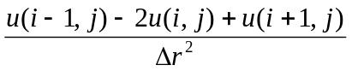 + 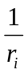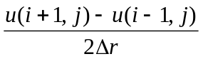 + 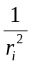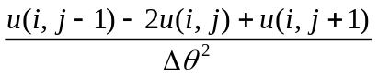 = 0

The value at the node (i, j) can be computed from

2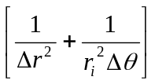u(i, j) = 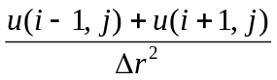+ + 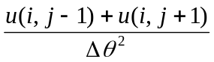

Example 6.5-1 _____________________________________________________

A semicircular plate with a radius of 1 has the straight boundary held at 0 while the curve boundary is held at 100. Find u(r, θ) with the grid given in Figure 6.5-2.

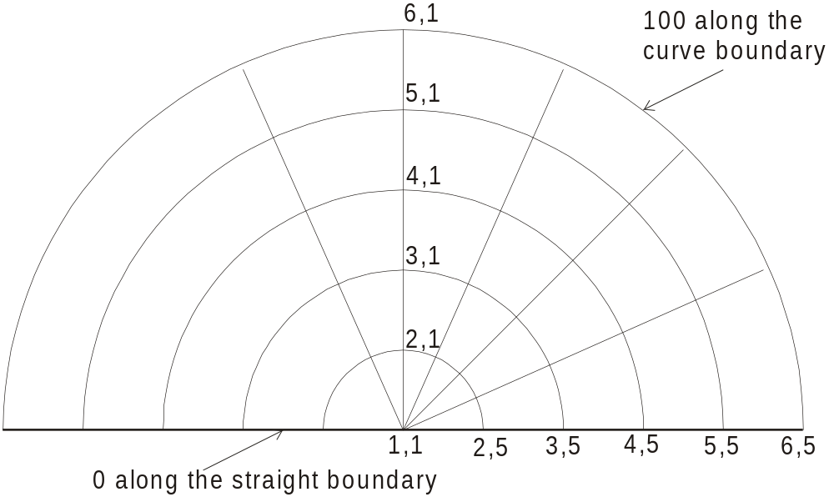
Figure 6.5-2 The nodes in a two dimensional, polar coordinate system.

Solution

The step size in the r direction is 0.2 and the step size in the θ direction is π/8. We can use the following equation to find u(r, θ)

2u(i, j) = + +

The node (1,1) is singular, it actually consists of all the nodes with r = 0 at any value of θ. The index i in the r direction vary from 1 to 6. However, we do not need to evaluate node (1,1) so that the coefficient for u(i, j), 2, is not required at this location. Therefore we can assign a vector r = [1 0.2 0.4 0.6 0.8 1.0] to evaluate .

The problem is symmetric with respect to the index j = 1 so that the nodes u(i, j = 1) can be computed from

2u(i, 1) = 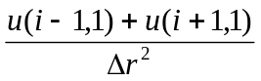+ 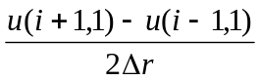 + 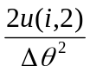

For the other nodes: i = 2 to 5 and j = 2 to 4

2u(i, j) = + +

Table 6.5-1 lists the MATLAB program using Gauss-Seidel iterations to solve for u(r, θ).

Table 6.5-1 Matlab program to solve for Laplace equation in polar coordinate -------------
%
% Example 6.5-1 (Gerald, example 7.21)
%
u=zeros(6,5);r=[1 .2 .4 .6 .8 1];
%
% Note: r(1) is never used in the calculation, a value is needed for the index
% since i change from 1 to 6, a zero will cause a division problem
%
ris=r.*r;
dt=pi/8;dr=.2;dts=dt*dt;drs=dr*dr;
coef=2*(1/drs+1.0./(dts*ris)); u(6,:)=100;
for k=1:100
usave=u;
for i=2:5
im=i-1;ip=i+1;
tem=(u(im,1)+u(ip,1))/drs+(u(ip,1)-u(im,1))/(2*dr*r(i));
u(i,1)=(tem+2*u(i,2)/(ris(i)*dts))/coef(i);
end
for i=2:5
for j=2:4
im=i-1;ip=i+1;
tem=(u(im,j)+u(ip,j))/drs+(u(ip,j)-u(im,j))/(2*dr*r(i));
u(i,j)=(tem+(u(i,j-1)+u(i,j+1))/(ris(i)*dts))/coef(i);
end
end
if max(abs(usave-u))<.001, break, end
end
fprintf('# of iteration = %g\n',k)
disp('u =');disp(u)

>> ex6d4d1
# of iteration = 46
u =
0 0 0 0 0
24.9864 23.2844 18.2316 10.1395 0
48.0379 45.5339 37.4499 22.3700 0
68.3658 66.1212 58.0545 39.1632 0
85.6589 84.4224 79.4574 63.6777 0
100.0000 100.0000 100.0000 100.0000 100.0000

